> restart:
> with(plots);
Warning, the name changecoords has been redefined

vvod ishodnyh dannyh
F(u)=cosu, U0(x)=x,

> F:=u->u*u*u/3;
> U0:=x->cos(x);
rewenie uravneniya u-U0(x-F(u)*t)=0 pri t=0

> implicitplot(u-U0(x)=0,x=-1..1,u=-1..1);
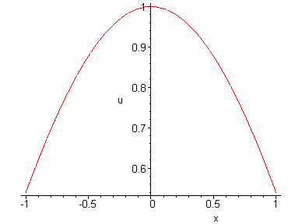
rewenie uravneniya u-U0(x-F(u)*t)=0 pri t=0.1

> implicitplot(u-U0(x-diff(u*u*u/3,u)*0.1)=0,x=-1..1,u=-1..1);
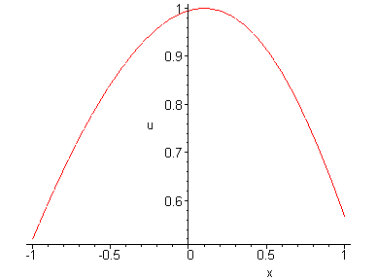
>
rewenie uravneniya u-U0(x-F(u)*t)=0 pri t=0.2

> implicitplot(u-U0(x-diff(u*u*u/3,u)*0.2)=0,x=-1..1,u=-1..1);
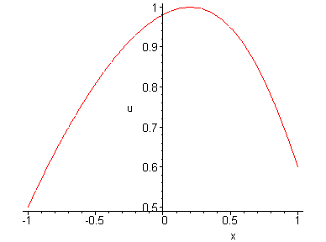
rewenie uravneniya u-U0(x-F(u)*t)=0 pri t=0.3

> implicitplot(u-U0(x-diff(u*u*u/3,u)*0.3)=0,x=-1..1,u=-1..1);
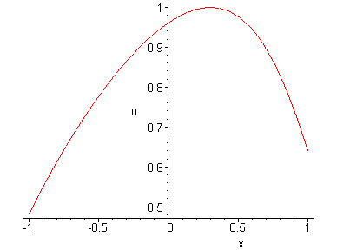
rewenie uravneniya u-U0(x-F(u)*t)=0 pri t=0.4

> implicitplot(u-U0(x-diff(u*u*u/3,u)*0.4)=0,x=-1..1,u=-1..1);
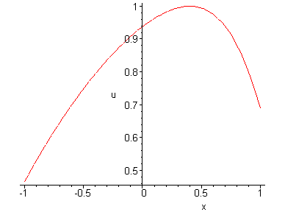
>
rewenie uravneniya u-U0(x-F(u)*t)=0 pri t=0.5

> implicitplot(u-U0(x-diff(u*u*u/3,u)*0.5)=0,x=-1..1,u=-1..1);
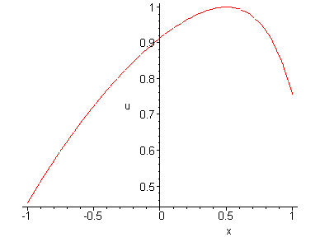
rewenie uravneniya u-U0(x-F(u)*t)=0 pri t=0.6

> implicitplot(u-U0(x-diff(u*u*u/3,u)*0.6)=0,x=-1..1,u=-1..1);
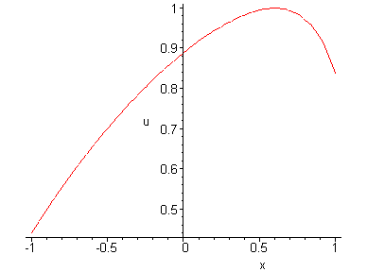
rewenie uravneniya u-U0(x-F(u)*t)=0 pri t=0.7

> implicitplot(u-U0(x-diff(u*u*u/3,u)*0.7)=0,x=-1..1,u=-1..1);
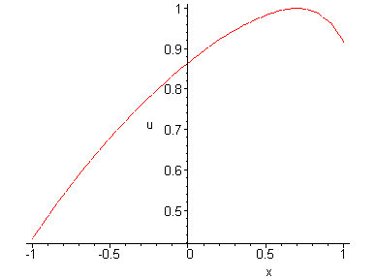
rewenie uravneniya u-U0(x-F(u)*t)=0 pri t=0.8

> implicitplot(u-U0(x-diff(u*u*u/3,u)*0.8)=0,x=-1..1,u=-1..1);
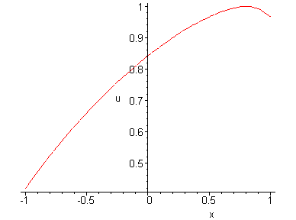
rewenie uravneniya u-U0(x-F(u)*t)=0 pri t=0.9

> implicitplot(u-U0(x-diff(u*u*u/3,u)*0.9)=0,x=-1..1,u=-1..1);
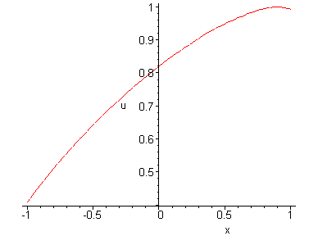
rewenie uravneniya u-U0(x-F(u)*t)=0 pri t=1

> implicitplot(u-U0(x-diff(u*u*u/3,u)*0)=0,x=-1..1,u=-1..1);
> A1:=implicitplot((u-U0(x-diff(u*u*u/3,u)*0.1)=0,x=-1..1,u=-1..1),style=line,color=red):
> A2:=implicitplot((u-U0(x-diff(u*u*u/3,u)*0.2)=0,x=-1..1,u=-1..1),style=line,color=orange):
> A3:=implicitplot((u-U0(x-diff(u*u*u/3,u)*0.3)=0,x=-1..1,u=-1..1),style=line,color=yellow):
> A4:=implicitplot((u-U0(x-diff(u*u*u/3,u)*0.4)=0,x=-1..1,u=-1..1),style=line,color=green):
> A5:=implicitplot((u-U0(x-diff(u*u*u/3,u)*0.5)=0,x=-1..1,u=-1..1),style=line,color=blue):
> A6:=implicitplot((u-U0(x-diff(u*u*u/3,u)*0.6)=0,x=-1..1,u=-1..1),style=line,color=black):
> A7:=implicitplot((u-U0(x-diff(u*u*u/3,u)*0.7)=0,x=-1..1,u=-1..1),style=line,color=red):
> A8:=implicitplot((u-U0(x-diff(u*u*u/3,u)*0.8)=0,x=-1..1,u=-1..1),style=line,color=green):
> A9:=implicitplot((u-U0(x-diff(u*u*u/3,u)*0.9)=0,x=-1..1,u=-1..1),style=line,color=black):
> A10:=implicitplot((u-U0(x-diff(u*u*u/3,u)*1)=0,x=-1..1,u=-1..1),style=line,color=brown):
> display({A1,A2,A3,A4,A5,A6,A7,A8,A9,A10});
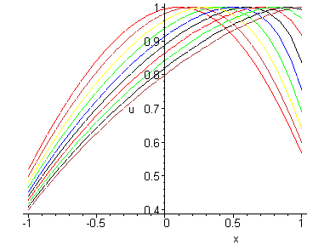
> animate(U0(x-diff(u*u*u/3,u)*t),u=-1..1,x=-1..1,t=0..1,frames=50,color=black);
Error, (in plot/options2d) unknown or bad argument: t = 0 .. 1

>

